1. Create XUNIT Test Project(Calculator)

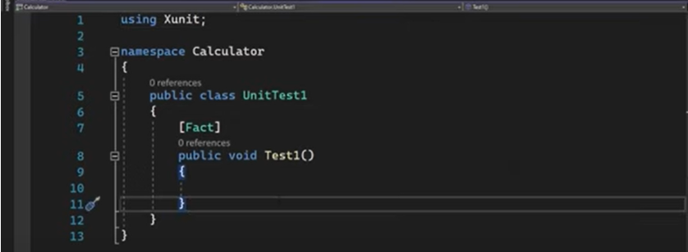

1. Create Method(Sum)

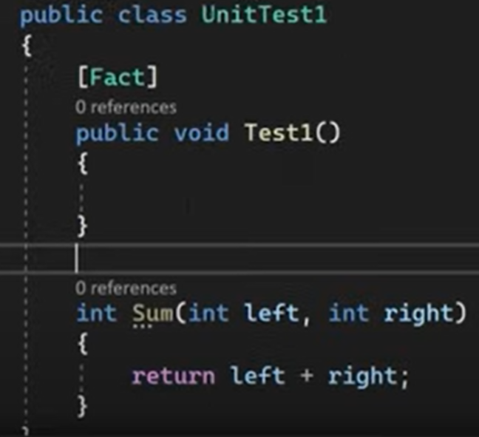

1. 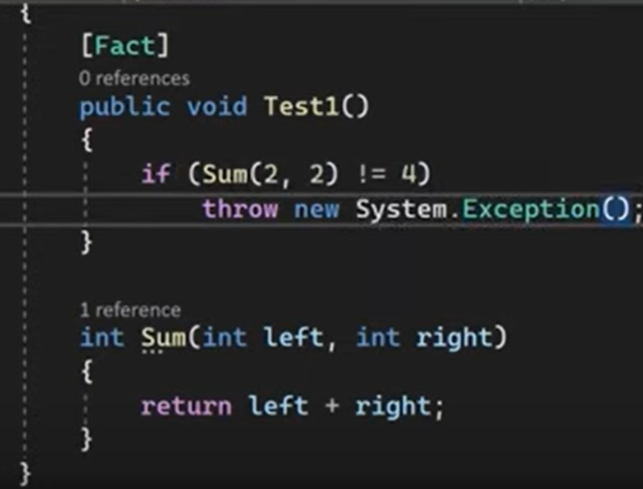Call Method(Sum)
2. Run Test(Test1)

* 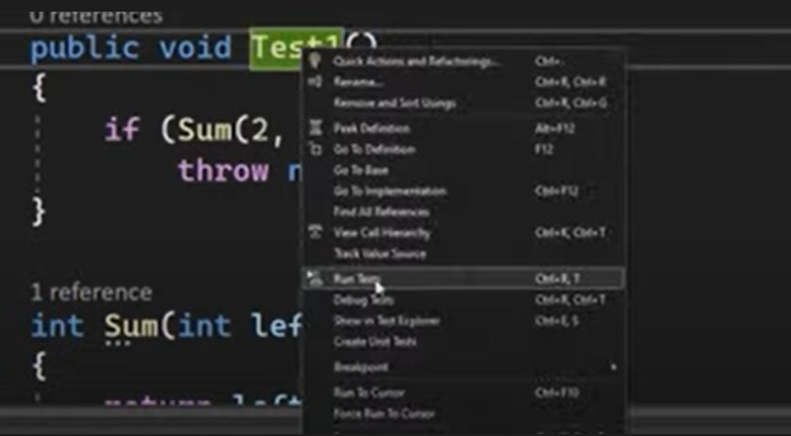Click right over Test1 and select Run Tests.

1. 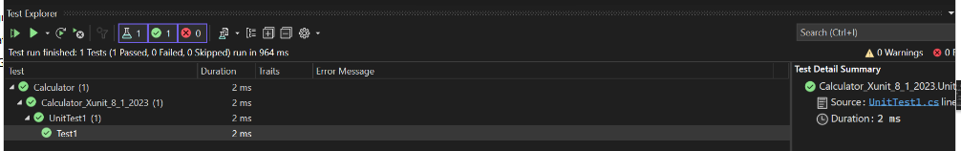Result
2. Changing if to !=5 and re-run to watch Result

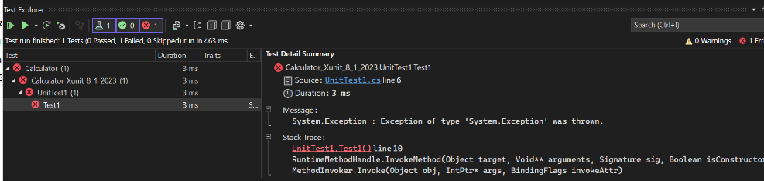

1. 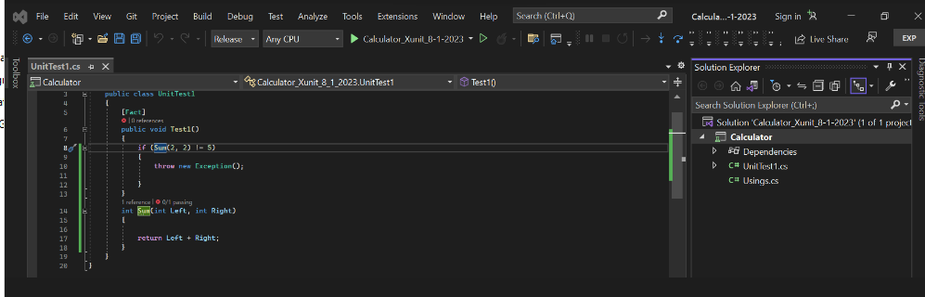Objects created till now.
2. Add a new project to call Test(Adding a C# Class Library (XClass)) called Domain

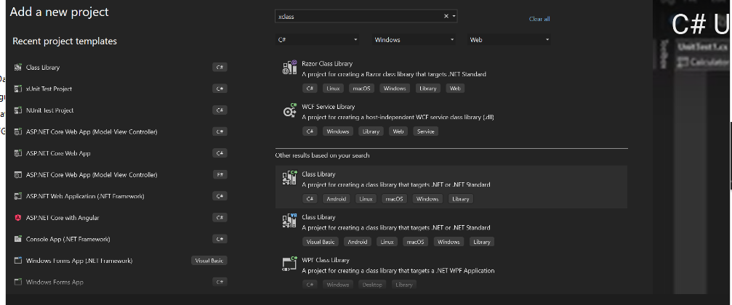

1. 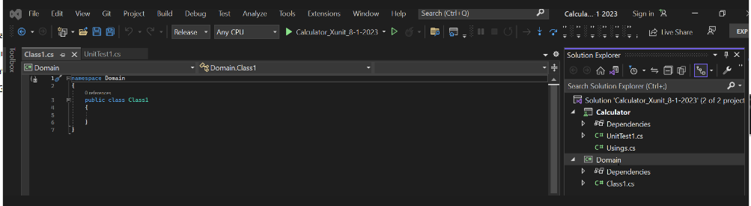New Folder
2. Rename Class1 to Calculator

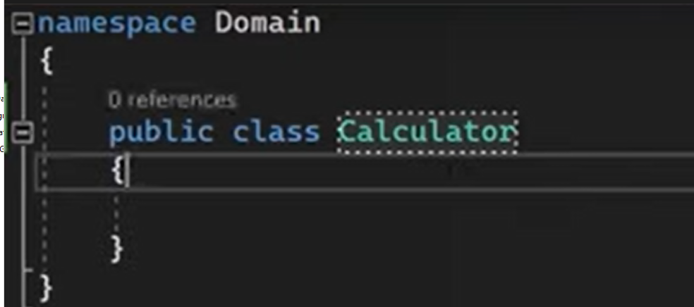

1. 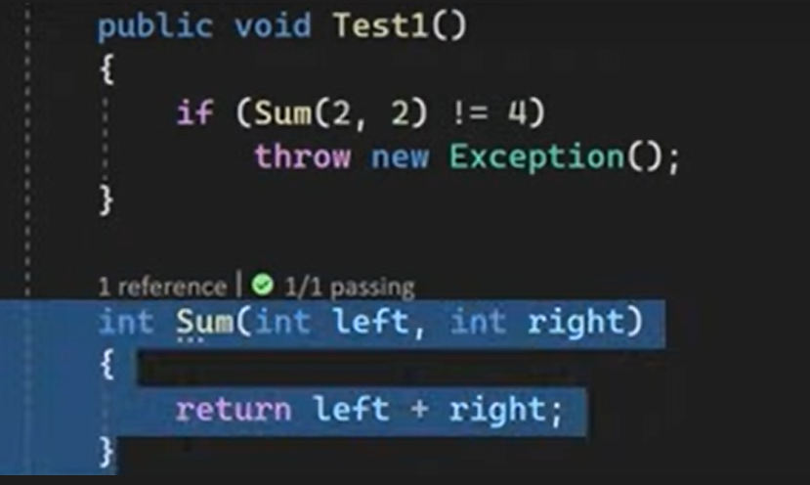Cut Sum method from Test method.
2. 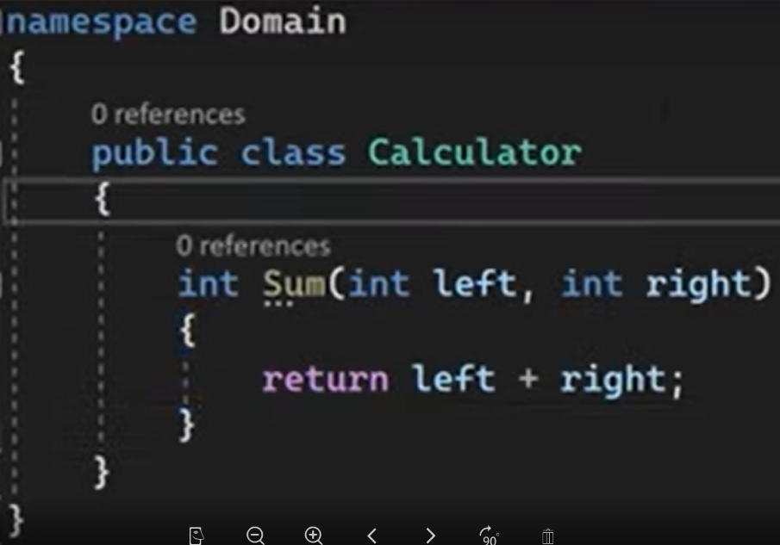Paste to Domain New project
3. 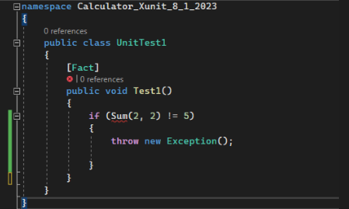Adding new reference to avoid this error
4. 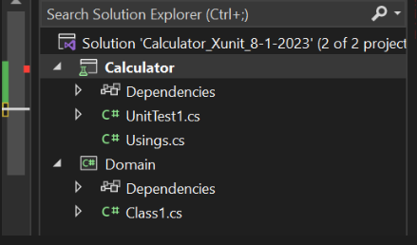Click right on Calculator(See square red color) and Add Project Reference

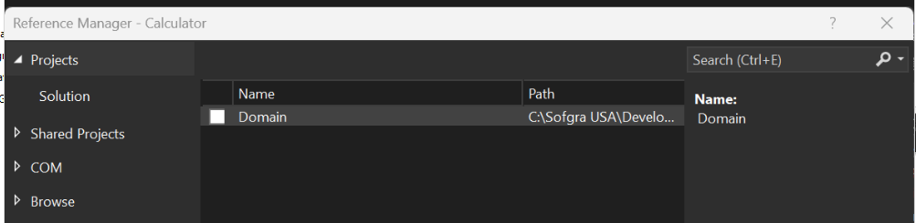

To delete your current [resume](https://www.fiverr.com/sahebali_/create-your-mid-career-resume-cover-letter-linkedin) from LinkedIn and upload a new one, you can follow these steps:

1. Log in to your [LinkedIn](https://www.fiverr.com/sahebali_/create-your-mid-career-resume-cover-letter-linkedin) account using your credentials.
2. Once you're logged in, click on your profile picture or the "Me" icon in the top right corner of the LinkedIn homepage. This will take you to your profile page.
3. On your profile page, click on the "More" button just below your profile picture. It looks like three dots in a row.
4. From the drop-down menu, select "Featured."
5. On the "Featured" page, you'll see a section called "Media." Look for the [resume file](https://www.fiverr.com/sahebali_/create-your-mid-career-resume-cover-letter-linkedin) you want to delete and click on the three dots in the top right corner of that file.
6. Click on "Remove from profile" from the options provided.
7. A confirmation prompt will appear asking if you want to remove the file. Click on "Remove" to confirm the deletion.

Now that you have deleted your previous resume, you can proceed to upload a new one by following these steps:

1. On your profile page, click on the "Add profile section" button, which is located just below your profile picture.
2. From the drop-down menu, select "Featured."
3. On the "Featured" page, click on the "Media" section.
4. Click on the "+" icon in the media section to add a new file.
5. A file upload dialog box will appear. Choose the new [resume file](https://www.jobseeker.com/en/resume?cq_src=google_ads&cq_cmp=15092453692&cq_term=resume%20online&cq_plac=&cq_net=g&cq_plt=gp&gad=1&gclid=CjwKCAjwsvujBhAXEiwA_UXnAD_dosDPNH3jk1Ey8Z05j1HH4LNq6k1mDgtHkNtvjvYhHQOFFXfhCBoCrwQQAvD_BwE) you want to upload from your computer and click "Open."
6. LinkedIn will then upload your new resume file. Once the upload is complete, you can add a title and description for the file if desired.
7. Click on the "Done" button to save your changes.

Your new resume is now uploaded and visible on your [LinkedIn profile](https://www.linkedin.com/in/sahebali12/). Remember to review the formatting and ensure the content is accurate before finalizing the upload.

My name is Manuel Algaba

I’m a Bachelor degree on computers Science

I have 23 years of experienced

I start to work in IBM technology as an Analyst Programmer

Since 2000 I move to Microsoft Technology, creating CRM systems using MSAccess mdb and accdb files, using VBA or VB6 for coding methods and show results on VBA process, through VB6 Windows form or Crystal Reports for print reports.

After 10 years I moved to VB.Net and C# through MS Data Base versions 2005, 2012,2018 and 2019, creating new data bases, new tables, and new fields type, relationship between tables.

Usually I connect direct to users group or managers in order to follow applications functionality or fix any issue working alone or getting help from other programmers and analysts.

I’m sure my experience will be useful for your company

Thank you.

I hope you are doing well and having a great week!

My name is Shivam Sharma and I work for C4 technical services. I think you'd be the perfect candidate for the role I'm trying to fill. I've attached the job description below; I hope this message finds you well.

Prime Therapeutics

VB.NET Developer

Contract: 3+

Remote

General Responsibilities:

Take the lead in analyzing and troubleshooting assigned system problems.

Support and maintain in-house legacy applications including modifications.

Design and develop desktop applications for deployment throughout the organization.

Manage and support systems throughout their full development lifecycle (concept to user support)

Migrate applications written using VBA and MS Access to enterprise standards and enterprise tools

Propose solutions that meet enterprise standards for business facing applications

Code, test, promote, and interact with impacted users ensuring that solution meets requirements.

Provide daily and weekly status to the development manager and application systems manager.

Qualifications and Experience:

Proficiency building VB.NET Desktop Applications is essential (8-10 years).

Experience writing advanced SQL & SQL procedures (including T-SQL, CTE, Table-valued functions, extended functions) using MS SQL Server is essential (8-10 years)

Working knowledge of VBA is required (8-10 years).

Experience with MS Access required (8-10 years).

Excellent organizational skills. Ability to communicate effectively with a wide variety of people in a professional manner, face to face, on the telephone and in writing.

Ability to demonstrate practical troubleshooting and problem analysis techniques. Good attention to detail and ability to show initiative.

Sincerely,

Shivam Sharma

Senior Technical Recruiter

C4 Technical Services

shivam.sharma@c4technicalservices.com

2935 Waters Road, Suite 100 Eagan, MN 55121, United States